Math 3 **3.8 Vertex Form** Unit 3

*SWBAT graph a quadratic equation in vertex form.*

Where (h, k) is the vertex

Vertex Form:

**Example 1:** State the vertex of the following functions.

1. 
2. 
3. 
4. 

**Example 2:** Write the equation in vertex form with the given information.

1. Vertex: (-6, 5); a = 12
2. Vertex: (4, -2); a = -3
3. Vertex: (-3, -8); a = 1
4. Vertex: (7, 2); a = .06
5. Vertex: (0, -8); a = 12
6. Vertex: (-6, 0); a = -9

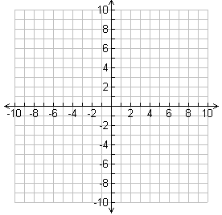

|  |  |
| --- | --- |
| **x** | **y** |
|  |  |
|  |  |
|  |  |
|  |  |
|  |  |

**Example 3:** Graph each of the following.

1. y = 1/2(x – 6)2 – 3

Opens: _________________

AOS: ___________________

Vertex: _________________

Domain: ________________

Range: _________________



|  |  |
| --- | --- |
| **x** | **y** |
|  |  |
|  |  |
|  |  |
|  |  |
|  |  |

1. y = – 3(x + 4)2 + 7

Opens: _________________

AOS: ___________________

Vertex: _________________

Domain: ________________

Range: _________________

**Writing a Quadratic Equation given a Vertex and a Point**

|  |
| --- |
| **Step 1:** Substitute the vertex into the equation for h and k.  **Step 2:** Substitute the given point into the equation for x and y.  **Step 3:** Simplify the equation and solve for a.  **Step 4:** Substitute the “a” into the equation written in Step 1. |

**Example 4:**  Write the equation of each parabola in vertex form: Vertex (1, 2); Point (2, -5)

**Example 5:** Write the equation of each parabola in vertex form: Vertex (-8, 3); Point (-1, 7)

**NC Final Exam Practice:** The towers of a suspension bridge are 800 feet apart and rise 162 feet higher than the road. Suppose that the cable between the towers has the shape of a parabola and is 2 feet higher than the road at the point halfway between the towers.

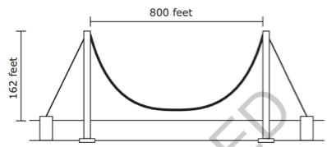

What is the approximate height of the cable 120 feet from either tower?

1. 80 feet
2. 74 feet
3. 22 feet
4. 16 feet