Math 3 3.6 Quadratic Inequalities Unit 3
SWBAT solve quadratic inequalities and write solutions in interval notation.

< | > | < | > | +∞ | −∞
Bracket or Parenthesis? | Bracket or Parenthesis? | Bracket or Parenthesis? | Bracket or Parenthesis? | Bracket or Parenthesis? | Bracket or Parenthesis?

Example 1: Solve the following given the inequality and the graph below.

- $-x^{2}+4>0$

- a) –x² + 6x – 9 > 0
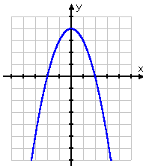
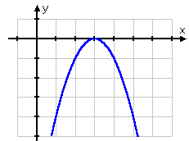
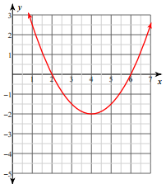
- $\frac{1}{2}x^{2}-4x+6≥0$

How to solve Quadratic Inequalities algebraically:
Step 1: Set inequality to zero
Step 2: Factor
Step 3: Solve for x-intercepts
Step 4: Sketch a graph based on the x-intercepts and the “a” value
Step 5: Write solution in interval notation

Example 2: Solve each of the following algebraically. Write your final answer in interval notation.

- ${2x}^{2}-18x>-24x$
- $x^{2} – 64 ≤ 0$
- ${6x}^{2}+11x+4≥ 0$

