Math 3 3.2 Graphing Exponentials and Logs Unit 3
EQ: How do you graph exponential and logarithmic functions as inverses on the coordinate plane?

Example 1: Find the inverse of the following. Remember, swap x and y, and solve for y again!

- y = log₅x
- y = log₇x - 1

- y = log₃(x-2)
- y = log₄(x + 3) – 8

Exponential Function |  | Logarithmic Function
A function whose unknown (x) is located in the exponent |  | The inverse function of an exponential function.
Transformations: y = a∙b^{x-h} + k |  | Transformations: y = a∙log_{b}(x-h)+k
Asymptote: |  | Asymptote:

Example 2: Graphing Exponential Functions and their Inverses

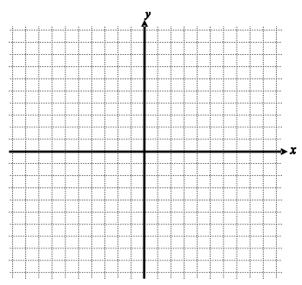
- $f(x)= 2^{x+1}$ $f^{-1}(x)=$

Transformations:
Asymptote:
Domain:
Range:

- $f(x)= -3^{x-1}+6$ $f^{-1}(x)=$

Transformations:
Asymptote:
Domain:
Range:

- $f\left(x\right)= \log_{2}x-3$ $f^{-1}(x)=$

Transformations:
Asymptote:
Domain:
Range:

- $f\left(x\right)= -\log_{4}\left(x+4\right)+2$ $f^{-1}(x)=$

Transformations:
Asymptote:
Domain:
Range:

