Math 1 **3.1 Solving Systems by Graphing** Unit 3 Day 1

**Systems of Equations:** A set of two or more equations using the same variables.

**Solving Systems by Graphing** (two variables only)

You can solve a system of equations with two variables (x and y) by graphing the equations set equal to ______.

|  |  |  |
| --- | --- | --- |
| **Name:** | **Name:** | **Name:** |
|  |  |  |
| **Solution:** | **Solution:** | **Solution:** |

**Solving a System of Equations by Graphing**

1. 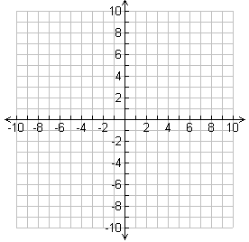What is the solution of the system? Use a graph. 
2.  What is the solution of the system? Use a graph. 

**Systems with Infinitely Many Solutions or No Solutions**

1. What is the solution of the system? Use a graph. 
2. What is the solution of the system? Use a graph. 

**Break Even Word Problems**

One satellite radio service charges $10 per month plus an activation fee of $20. A second service charges $11 per month plus an activation fee of $15. For what number of months is the cost of either service the same?

At Comerica ballpark, the Detroit Tigers charge $5 dollars for each ticket and expects to make $1400 in concessions. The team must pay its players $2000 and pay all other workers $1600. Each fan gets a free bat that costs the team $3 per bat. How many tickets must be sold to **break even**?

Mr. McDowell invested $14,000 in equipment to print yearbooks for Ardrey Kell High School. Each yearbook costs $7 to print and sells for $35. How many yearbooks must he sell before he **breaks even**?

**Lesson Check**: Solve by graphing.

1. 



1. 



1. 



1. Suppose you invest $10,410 in equipment to manufacture a new video game. Each game costs $2.65 to manufacture and sells for $20. How many games must you make and sell before your business breaks even?
2. The class of 2015 decides to start a T-shirt company. After initial expenses of $280, the purchase each T-shirt for $3.99. They sell each T-shirt for $10.99. How many must they sell to break even?