Math 3 **3.10 Focus and Directrix** Unit 3

*SWBAT convert quadratic equations into Standard Form, Intercept Form, or Vertex Form.*

**Parabola:** the set of all points in a plane that are the same distance from a fixed line and a fixed point not on the line.

|  |  |  |  |
| --- | --- | --- | --- |
| **Vertical Parabola** | | **Horizontal Parabola** | |
|  | |  | |
| Opens up when a is: | Opens down when a is: | Opens right when a is: | Opens left when a is: |
| Formula for a vertical parabola: | | Formula for a horizontal parabola: | |

|  |  |
| --- | --- |
| **Focus of a Parabola:** The fixed point (x, y) inside of the parabola, located on the axis of symmetry. | **Directrix:** The fixed line used to define a parabola.  The parabola never crosses the directrix. |
| Each point of the parabola is the same distance from the focus and the directrix. | |

**Distance from Focus to Vertex = Distance from Directrix to Vertex =**

|  |
| --- |
| *If given the vertex and the focus, draw a picture to determine which way the graph must open.*  *The focus is always INSIDE of the parabola!* |

**Example 1:** Write an equation of a parabola with vertex at the origin and the given focus:

1. Focus at (6, 0)
2. Focus at (0, 7)
3. Focus at (2, 0)

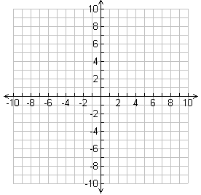

Equation:

Equation:

Equation:

|  |
| --- |
| To identify the vertex, focus, and the directrix, begin by labeling the a, h, and k values. Then draw a rough sketch from there, using the (h, k) to determine the vertex, and the *a* to determine the direction of opening.  The distance between the vertex and the focus is . |

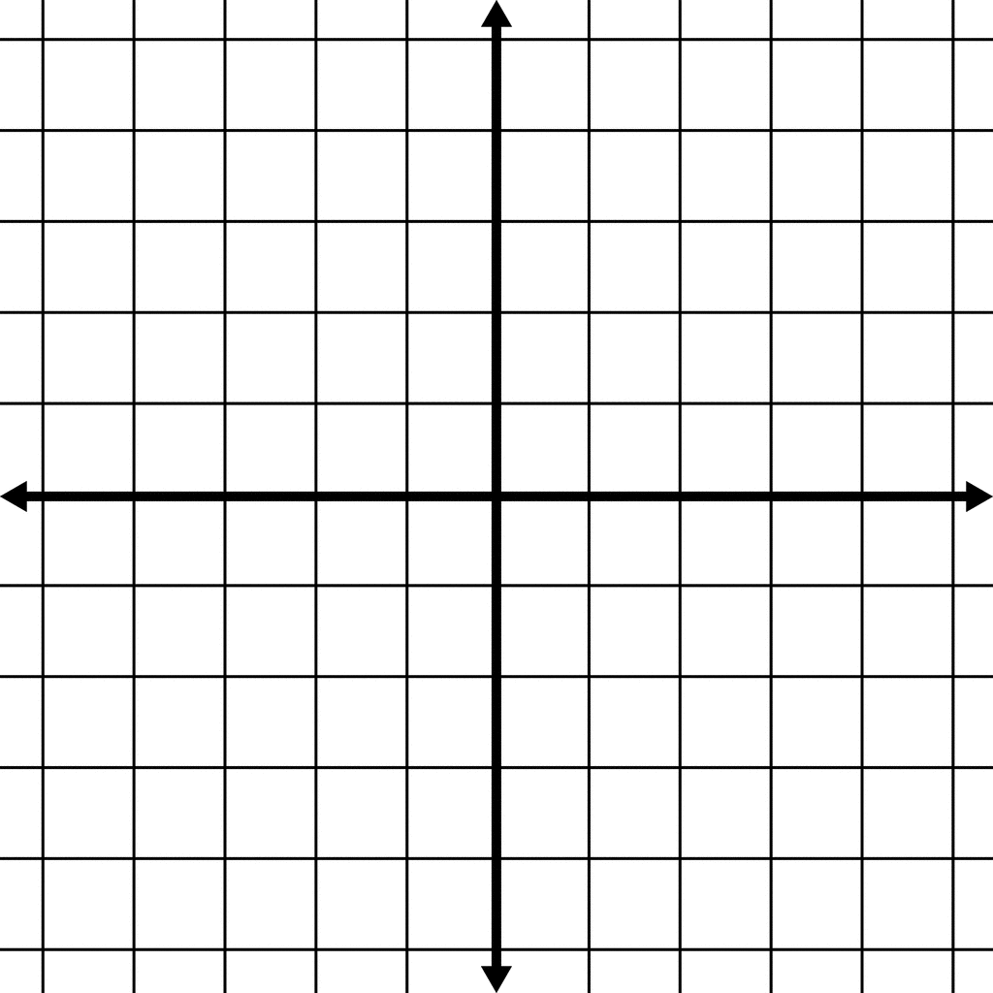**Example 2:** Identify the vertex, the focus, and the directrix of the parabola with the given equation. Then sketch the graph of the parabola.

1. 

Vertex =

Focus =

Directrix =

1. 

Vertex =

Focus =

Directrix =

|  |
| --- |
| If given the vertex and the directrix, draw a picture to determine which way the graph must open. The distance between the vertex and the directrix is .  The directrix is always OUTSIDE of the parabola, and the parabola will never cross the directrix. *If given the vertex and the focus, draw a picture to determine which way the graph must open.*  *The focus is always INSIDE of the parabola!* |

**Example 3:** Write an equation of a parabola with vertex at the origin and the given directrix:



1. Directrix at x = -3
2. Directrix at 

|  |
| --- |
| If given the vertex and the focus, and the vertex is not at the origin, draw a rough sketch of the parabola to determine which way it opens. Remember that the focus is inside of the parabola! |

**Example 4:** Write an equation of a parabola with the given vertex and the given focus:

1. Vertex at (0, 3) and Focus at (-8, 3)
2. Vertex at (7, 2) and Focus at (7, -2)

