Math 1 2.6 Parallel and Perpendicular Lines Unit 2 Day 6

SWBAT classify lines as parallel, perpendicular, or neither, and write the equations of parallel and perpendicular lines.

 | Parallel Lines | Perpendicular Lines
Picture (Graph) | 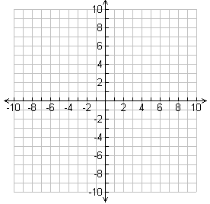
Things you already know
Definition
Example

Writing an Equation of a Parallel Line: Find the parallel slope first, then substitute the point into y = mx + b.
- A line passes through (12, 5) and is parallel to the graph of $y=\frac{2}{3}x-1$. What equation represents the line in slope-intercept form?

- A line passes through (-3, -1) and is parallel to the graph of $y=2x+3$. What equation represents the line in slope-intercept form?

Writing an Equation of a Perpendicular Line: Find the perpendicular slope first, then substitute the point into y = mx + b.
- Write the equation of a line that passes through (2, 4) and is perpendicular to the graph of $y=\frac{1}{3}x-1$.

- A line passes through (1, 8) and is perpendicular to the graph $y=2x+1$. What equation represents the line in slope-intercept form?

Parallel and Perpendicular Lines Worksheet
Write the equation in slope intercept form of the line parallel and line perpendicular to given line through given point. Parallel Perpendicular
1) y = 4x + 7 (─2, ─9) _______________________________ _______________________________

2) 2x ─ 5y = 10 (3, ─7) _______________________________ _______________________________

3) 3x + 4y = 16 (12, ─5) _______________________________ _______________________________

Write the equation of the perpendicular bisector of.
4) A (3, ─6) B (7, 2) 5) A (2, 5) B (6, ─7)

______________________________ ______________________________
6) A (8, 1) B (0, ─1) 7) A (7, 9) B (1, 5)

______________________________ _______________________________

