Math 3 2.6 Inverse Functions and Relations Unit 2
EQ: How can we find the inverse of functions and determine if a function is one-to-one?

The speed limit for driving in a school zone is 20mph. That seems so slow if you’re riding in a car. But have you ever wondered how quickly you could come to a complete stop going that speed (even if you have super quick reflexes)? It would take you over 13 feet! The speed of a vehicle s and the stopping distance d are related by the function $s\left(d\right)=\sqrt{30d}$.

Fill in the table of values for s(d). Round to the nearest whole number. Then, graph s(d) and answer the questions.
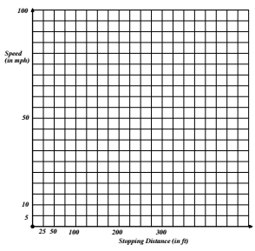

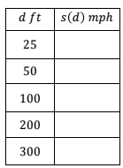

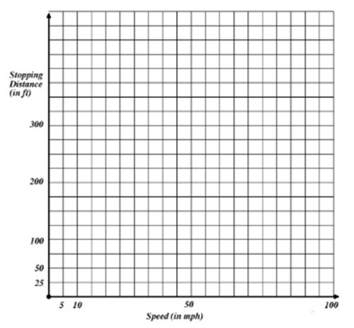
If you were a police officer investigating an accident, you would be able to measure the length of the skid marks on the road and then approximate the speed of the driver. The driver swears he was sure he was going under 60 mph. The tire marks show a pattern for 150 feet. Is the driver’s sense of his speed accurate? Justify your answer.

Use your answers in the problem to make a graph of stopping distance as a function of speed.

How are the two graphs related?

Inverse Relations:

Vertical Line Test:

Horizontal Line Test:

One-to-One:

Example 1: Are the following inverses of each other?
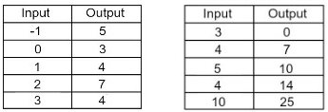
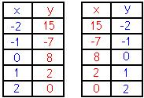

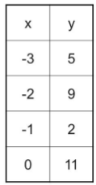
Example 2: Are the following one-to-one?

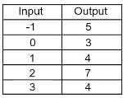

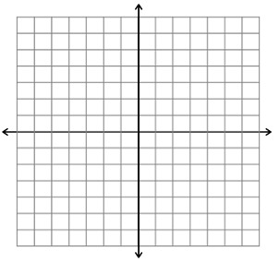
Example 2: Graph y = x² Graph the inverse:

- Is the inverse a function?
- Is the function one-to-one?

Example 3: Graph y = x + 2 Graph the inverse:

- Is the inverse a function?
- Is the function one-to-one?

You Try! Draw the graph of the inverse function for each of the functions shown below on the same coordinate plane.
