Math 1 2.5 Standard Form Unit 2 Day 5

Standard Form of a Linear Equation: The equation Ax + By = C, where A, B, and C are integers and A and B are not both zero.
X-intercept: The x-coordinate of a point where the graph crosses the x-axis.
Ex: (x, 0)

Y-Intercept: The y-coordinate of a point where the graph crosses the y-axis.
Ex: (0, y)

Ax +By = C

Finding X- and Y-Intercepts
Use the cover-up method to solve for the x- and y-intercepts of the following equations, and then graph.

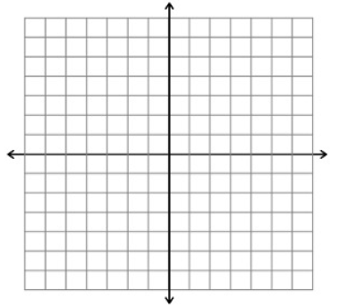
- 2x + 3y = 12
- 6x – 5y = 30

x-int: _________ x-int: _________
y-int: _________ y-int: _________

- 10x + 12y = 48
- 2x – 7y = 21

X-int: ______ y-int: _____ X-int: ______ y-int: _____

Graphing Horizontal and Vertical Lines
What is the graph of each equation?

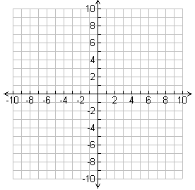
- x = 3
- y = 3

- x = -1
- y = -2

Transforming into Standard Form
What is the equation of the line in standard form?

- y = 1/2x – 6
- y – 3 = 2 (x + 3)

Writing the Equation of a Line in Three Different Forms
Given (3, 0) and (4, 2), write the equation in the following forms:
- Point-Slope Form:

- Slope Intercept Form:

- Standard Form:

Modeling Using Equations
A media download stores sells songs for $1 each and movies for $12. You have a gift card for $60. Write and graph an equation that describes the items you can purchase. What are three combinations of numbers of songs and movies you can purchase?

