Math 3 2.5 Graphing Radicals Unit 2 Day 5
SWBAT graph radical functions, state the transformations, and find the domain, range, and end behavior.

Families of Radical Functions
Radical function: A function that can be written in the form $f\left(x\right)=\sqrt[n]{x-h}+k, where a≠0$. For even values of n, the domain of a radical function is the real numbers x > h.  Square Root Function: a function that can be written in the form $f\left(x\right)=a\sqrt{x-h}+k, where a≠0$. The domain of a square root function is all real numbers x > h. | SQUARE ROOT RADICAL  Parent Function $$y=\sqrt{x}$$ $$y=\sqrt[n]{x}$$  Reflection in x-axis $$y=-\sqrt{x}$$ $$y=-\sqrt[n]{x}$$  Stretch: a > 1 Shrink: 0 < a < 1 $$y=a\sqrt{x}$$ $$y=a\sqrt[n]{x}$$  Translation Horizontal by h Vertical by k $$y=\sqrt{x-h}+k$$ $$y=\sqrt[n]{x-h}+k$$

Graphing a Square root function

EXAMPLE #1: Graph $y=2\sqrt{x+3}-1$
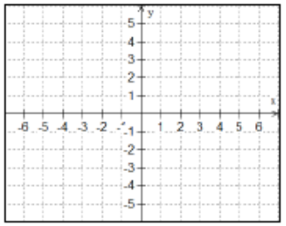
Translations:

Domain:

Range:

End Behavior:

EXAMPLE #2: Graph $y=-\frac{1}{2}\sqrt{x-1}+4$
Translations:

Domain:

Range:

End Behavior:
Graphing a cube root function

EXAMPLE #3: Graph $y=\sqrt[3]{x-2}$
Translations:

Domain:

Range:

End Behavior:

EXAMPLE #4: Graph $y=1-\frac{1}{2}\sqrt[3]{x+3}$
Translations:

Domain:

Range:

End Behavior:

EXAMPLE #5: The population of Corpus Christi, Texas, between 1970 and 2005 can be modeled by the function $P(x)=75000\sqrt[3]{x-1950}$, where x represents the year. In what year was the population of Corpus Christi 275,000?
Solve by Graphing: Solve Algebraically:

