Math 3 2.4 Applications of Piecewise Functions Unit 2
EQ: How can we write and graph piecewise functions given a real-life situation?

Writing a Piecewise Function
Write equations for the piecewise functions whose graph is shown.

Graph | Equation of Pieces | Domain for Pieces | Piecewise Function
 |  |  | 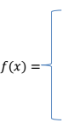
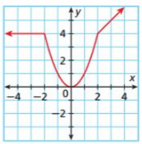
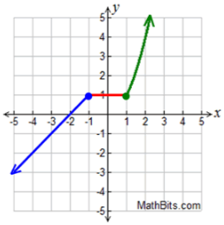
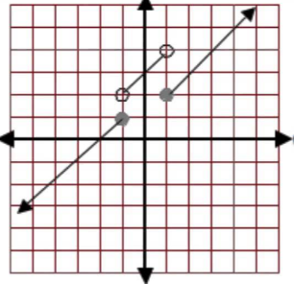

Using a Piecewise Function

You have a summer job that pays time and a half for overtime. That is, if you work more than 40 hours per week, your hourly wage for the extra hours is 1.5 times your normal hourly wage of $7.

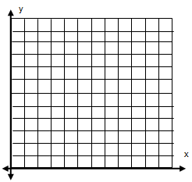
Write and graph a piecewise function that gives your weekly pay, P, in terms of the number, h hours you work.

What is the domain?

- What is the reasonable domain?

How much will you get paid if you work 45 hours?

Your favorite dog groomer charges according to your dog’s weight. If your dog is 15 pounds and under, the groomer charges $35. If your dog is between 15 and 40 pounds, she charges $40. If your dog is over 40 pounds, she charges $40, plus an additional $2 for each pound.

- What is the domain?

- What is the reasonable domain?
- What would you be charged if your dog weighed 60 lbs?

