Math 1 2.4 Slope-Intercept Form Unit 2 Day 4

y = mx + b

Slope: ___________________________
y-intercept: Where the graph
crosses the y-axis
( x , y ) = __________________________________________________________
- The ordered pair stays as x and y when writing the equation

Identifying Slope and Y-Intercept
What are the slope and y-intercept of the following equations?

- y = 2x + 5
- y = -5x – 1
- y = 1/3x + 2
- y = x/2 – 3
- 2y = 6x + 4

Graphing Equations of Lines in Slope-Intercept Form
Graph the following lines:

- y = 2x – 1
- y = 1/2x + 5
- y = -3x – 2

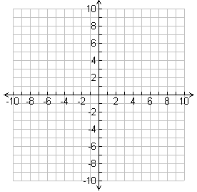

Writing Equations in Slope-Intercept Form
Write the equation of the line with the following slope and y-intercept:

- slope = ½;
y-intercept = 2
- slope = 3;
y-intercept = -2
- slope = -4;
y-intercept = 0
- slope = 0;
y-intercept = 9
- slope = 0;
y-intercept = 0

Writing Equations with a Given Point and Slope
Write the equation of the line that goes through each given point and slope.
- Write the equation of a line that goes through the point (2, 3) and has a slope of 5.

- Write the equation of the line that goes through the points (2, 1) and (5, -8).

Math 1 2.5 Point-Slope Form Unit 2 Day 5

Point Slope Form: An equation of a nonvertical line with slope m and through point (x₁, y₁)
(y – y₁) = m(x – x₁)

Graphing Using Point-Slope Form

- What is the graph of the equation:
$$y-1=\frac{2}{3}(x-2)$$
- What is the graph of the equation:
$y+7=-\frac{4}{5}(x-4)$

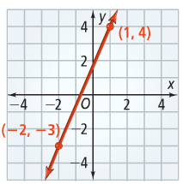
Using Two Points to Write an Equation
What is the equation of the line to the right?

Writing an Equation in Point-Slope Form
- Convert the following equation from Point-Slope to Slope-Intercept: $y-3=4(x+1)$

- Convert the following equation from Point-Slope to Slope-Intercept: $y+7=12(x-2)$

Using a Table to Write an Equation
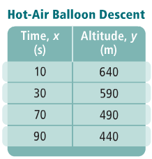
The table shows the altitude of a hot-air balloon during its linear descent. What equation in slope-intercept form gives the balloon’s altitude at any time? What do the slope and y-intercept represent?

