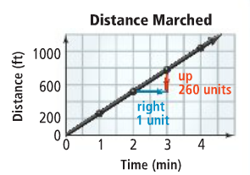
Math 1 2.3 Slope and Rate of Change Unit 2 Day 3

SLOPE = ____________________ = _______
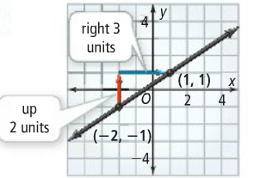
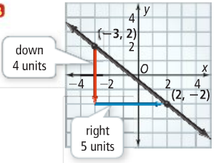
Example 1: What is the slope of each line?

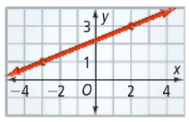
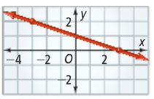
Example 2: What is the slope of each line?

- In part (A) of example 2, pick two new points on the line to find the slope. Do you get the same slope?

Slope Formula= _______ = ____________________

Where $x_{2}-x_{1}≠0$
IMPORTANT! The x-coordinate you use first in the denominator must belong to the same ordered pair as the y-coordinate you use in the numerator.
Example 3: Find the slope for each of the following.

- What is the slope of the line through (-1, 0) and (3, -2)?
- What is the slope of the line through (1, 3) and (4, -1)?

Example 4: Horizontal and Vertical Lines

- What is the slope of the following graph?
- What is the slope of the following graph?

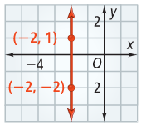
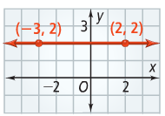

Concept Summary: All About Slope
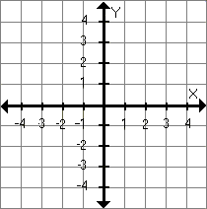  Positive Slope: A line with positive slope that slants upward from left to right. | Negative Slope: A line with negative slope that slants downward from left to right.
Horizontal Slope: A line with a slope of zero is horizontal. | Undefined Slope: A line with an undefined slope is vertical

Classwork: Complete each of the following in class for credit.

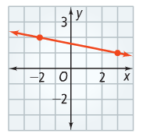
- What is the slope of the line?
- What is the slope of the line through (-1, 2) and (2, -3)?

- What characteristic of a graph represents the rate of change? Explain.

- Give an example of a real-world situation that you can model with a horizontal line. What is the rate of change for the situation? Explain.

- How does finding a lines slope by counting units of vertical and horizontal change on a graph compare with finding it using the slope formula?
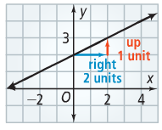

- A student calculated the slope of the line to be 2. Explain the mistake. What is the correct slope?

