Math 3 2.3 Piecewise Functions Unit 2

*EQ: How can we evaluate piecewise functions and graph piecewise functions on the coordinate plane?*

## **Piecewise Functions:** A function represented by _________________ each corresponding to a __________________.

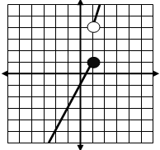

2x – 1, if x ≤ 1

3x + 1, if x > 1

**Example:**

**Evaluating a Piecewise Function Algebraically**

**Example 1:** Evaluate f(x) for each of the following.

x + 2, if x < 2

2x + 1, if x ≥ 2

f(x) =

1. f(0) =
2. f(2) =
3. f(4) =

**Example 2:** Evaluate f(x) for each of the following.



1. f(-4) =
2. f(6) =
3. f(-2) =
4. f(0) =

**You Try!** Evaluate f(x) for each of the following.



1. f(8) =
2. f(0) =
3. f(4) =
4. f(5) =

**Evaluating a Piecewise Function Graphically**

**Example 3:** Evaluate f(x) for each of the following.

**You Try!** Evaluate f(x) for each of the following.

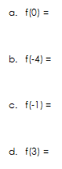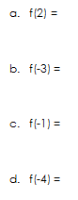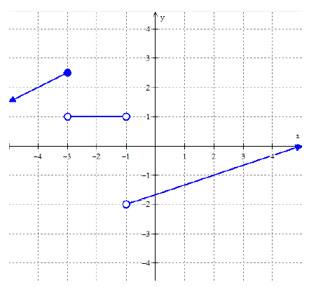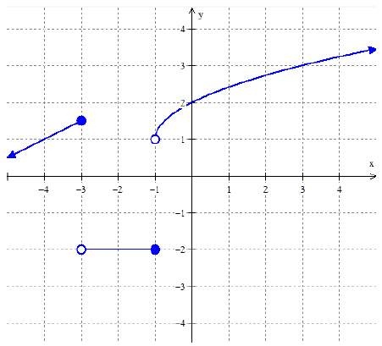

**Graphing Piecewise Functions**

**Example 4:** Graph the following piecewise function.

**Example 5:** Graph the following piecewise function.

 

**You Try!** Graph the following piecewise function.

