Where have we seen imaginary numbers before? |  |  | Imaginary Numbers
Simplifying Powers  of i’s |  |  | The Patterns of Powers, Signs, 1’s, and i’s
Imaginary Numbers  Until now you have been told you cannot take the square root of a negative number. Now, however, you can take the square root of a negative number, but it involves a new number called “i” which is called the imaginary number.  $$i=\sqrt{-1}$$  Simplify:  Ex. $\sqrt{-25}$ Ex. $\sqrt{-9}$ Ex. $\sqrt{-40}$ Ex. $\sqrt{-70}$ |  | Where have we seen imaginary numbers before?  In Math 1, we learned the quadratic formula and the discriminant. The discriminant, b² – 4ac, determines the number of solutions and the type of solutions we will have with a quadratic equation.  Number and type of Real solutions to a Quadratic Function:  Two Real One Real No Real  b² – 4ac > 0 b² – 4ac = 0 b² – 4ac < 0  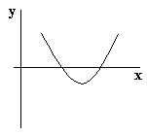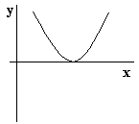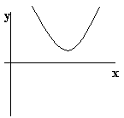
The Patterns of Powers, Signs, 1’s, and i’s  Look for the patterns below:  $i^{1}=$ $i^{5}=$  $i^{2}=$ $i^{6}=$  $i^{3}=$ $i^{7}=$  $i^{4}=$ $i^{8}=$  What patterns do you see? _________________________________________ |  | Simplifying Powers of i’s  To simplify i to any power, try to get the exponent to an even power by removing an i if the exponent is odd, and then reverse the “power to a power” rule by dividing by two. Simplify using the properties of algebra.  Ex. $i^{17}=$ Ex. $i^{98}=$  Ex. $i^{39}=$ Ex. $i^{65}=$

