Math 3 2.2 Parent Functions and Transformations Unit 2
EQ: What is a parent function? How do we apply transformations to parent functions?

Parent Functions:

Parent Function | Graph | Parent Function | Graph
Linear  Function | 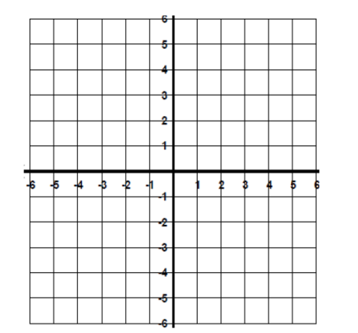 | Absolute Value Function
Quadratic  Function |  | Square Root Function
Cubic  Function |  | Cube Root  Function
Reciprocal  Function |  | Greatest Integer Function

Transformations:

y = af(x-h)+k

- “a” value determines whether the graph has vertically ____________________ or _______________________.
- “h” value determines whether the graph has shifted ___________________ or ___________________.
- “k” value determines whether the graph has shifted ___________________ or ___________________.
- –f(x) demonstrates a reflection across the _________ axis.
- f(–x) demonstrates a reflection across the _________ axis.

Directions: State the parent function and the types of transformations. Then, graph the parent function and the transformed function on the graph below.

Example 1: y = (x – 3)² + 2
Example 2: y = –|x – 3|
Example 3: y = 3^{x + 1}

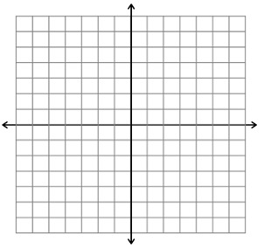

Directions: Write the equation of the function with the given transformations.

- Quadratic Function; reflection across the x-axis, left 3, down 2

- Absolute Value Function; reflection across the y-axis, vertical stretch by 8

- Square Root Function; right 7, up 9, vertical compression of ½

