Activity 2.1: Parts of a Graph Name: _____________________________
Math 3

X-Intercept: | Y-Intercept: | Maximum/Minimum: | Vertex:
When the value of “y” is zero; where the graph crosses the x-axis. | When the value of “x” is zero; where the graph crosses the y-axis. | The y-value where a graph comes to a high point or low point | Highest or lowest point of a graph (x, y)
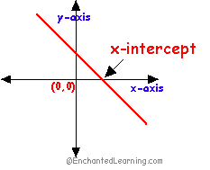 | 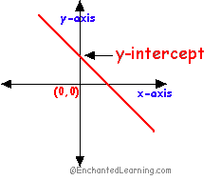 | 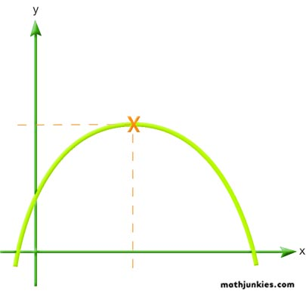 | 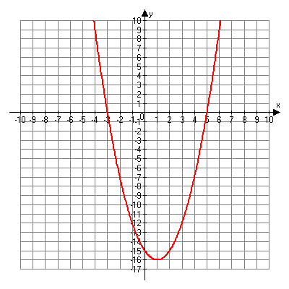  Vertex (x, y)

Directions: In the following activity, fill in the table, plot the points on the graph, and find the maximum or minimum, vertex, x-intercepts, and y-intercepts. Then state the shape and answer the question at the end of each category.

Example: $f\left(x\right)={(x+1)}^{2}-9$ Shape: _______
x | -6 | -5 | -4 | -3 | -2 | -1 | 0
y

x-intercept:

y-intercept:

Max or Min:

Vertex:

Domain:

Range:

Interval Increasing:

Interval Decreasing:

- What similarities do you see between the vertex and the equation?

- What part of the equation do you think gives the graph its shape?

Absolute Value #1: $f\left(x\right)=\left|x-4\right|-2$ Shape: _______
x | 1 | 2 | 3 | 4 | 5 | 6 | 7
y

x-intercept:

y-intercept:

Max or Min:

Vertex:

Domain:

Range:

Interval Increasing:

Interval Decreasing:

- What similarities do you see between the vertex and the equation?

- What part of the equation do you think gives the graph its shape?

Quadratic #1: $f\left(x\right)={-(x-2)}^{2}+1$ Shape: _______
x | -1 | 0 | 1 | 2 | 3 | 4 | 5
y

x-intercept:

y-intercept:

Max or Min:

Vertex:

Domain:

Range:

Interval Increasing:

Interval Decreasing:

- What similarities do you see between the vertex and the equation?

- What part of the equation do you think gives the graph its shape?

