Math 3 2.1 Features of Functions Unit 2
EQ: What is a function? How do we state the domain, range, and intervals in/decreasing?

Relation:
Function:
Domain:
Range:
Determining if a Set of Ordered Pairs is a Function
Example 1: What are the domain and range of this relation? {(-4, 0), (-3, 1), (0, -2), (1, 2), (3, 3)}
Domain: Range: Is this a function?

Determining if a Graph is a Function
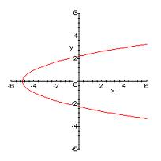
Example 1: Are the following functions? Explain why or why not.

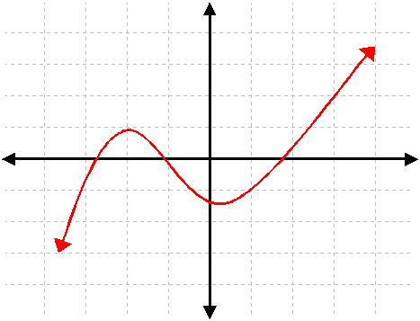

Determining if an Equation is a Function
Two things cannot be true:
- y cannot be in absolute value bars
- y cannot be raised to an even power
Example 2: State whether the following equations are functions:
- y = x² + 2 b. x = y² – 3y c. y = 3^{x}

Constant, Increasing, and Decreasing Intervals
Intervals Increasing:
Intervals Decreasing:
Constant Intervals:
Example 3: Given each representation of a function, determine the domain and range. Then, determine the intervals in which the function is increasing, decreasing, and/or constant.

