Math 3 1.6 Absolute Value Equations Unit 1

*SWBAT solve absolute value equations and check solutions using substitution.*

**Absolute Value:**

Absolute value graphs have three possible solutions: no solution, one solution, or two solutions.

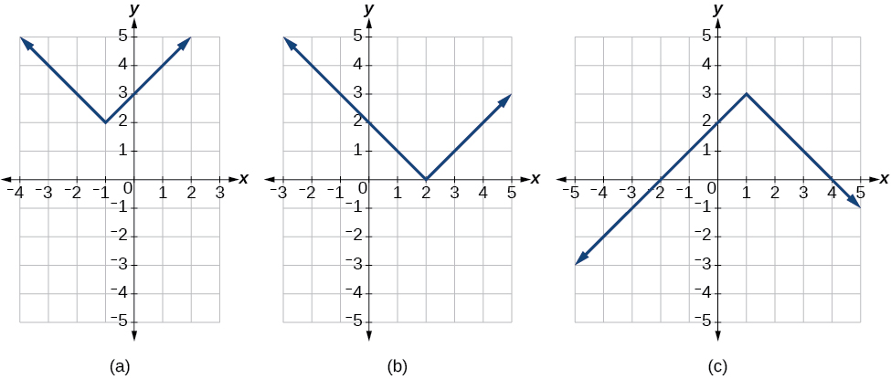

Solving absolute value equations by hand is almost the exact same as solving regular equations with one major difference. In most cases you have *2 solutions*.

**Example:** |x| = 5

We know that when x = 5, |5| will also equal 5, but it is also true that |-5| will equal 5. So, for |x| = 5, x = {-5, 5}. They both work.

Isolating absolute value equations is similar to isolating an equation for x.

**Regular Equations** **Absolute Value Equations**

1a) 5x + 9 = 144

1b) 5|3x – 6|+ 9 = 144

2a) $\frac{x}{7}-3=1$

2b) $\frac{\left|12x-8\right|}{7}-3=1$

3a) $\frac{2}{3}x-11=-3$

3b) $\frac{2}{3}\left|2x-10\right|-11=-3$

4a) $\frac{4x-5}{3}=9$

4b) $\frac{4\left|8x-16\right|-5}{3}=9$

**How to Solve Absolute Value Equations**

1. Isolate the absolute value.

***NOTE:*** *Never distribute into the absolute value bars!*

1. Split the equation into two, with one positive and one negative.
2. Check your solution by substituting your answer(s) into the original problem!

**Example 1:** Solve |2x+6|– 3 = 13

**Example 2:** Solve 4|5x –10|+ 23 = 3

**Example 3:** 

**You Try! **