Math 3 1.2 Parent Functions and Transformations Unit 1 Day 2

Parent Functions:

Tape Parent Function Foldable Here!

Transformations:

y = af(x-h)+k

- “a” value determines whether the graph has vertically ____________________ or _______________________.
- “h” value determines whether the graph has shifted ___________________ or ___________________.
- “k” value determines whether the graph has shifted ___________________ or ___________________.
- –f(x) demonstrates a reflection across the _________ axis.
- f(–x) demonstrates a reflection across the _________ axis.

Directions: State the parent function and the types of transformations. Then, graph the parent function and the transformed function on the graph below.

Example 1: y = (x – 3)² + 2
Example 2: y = –|x – 3|
Example 3: y = 3^{x + 1}

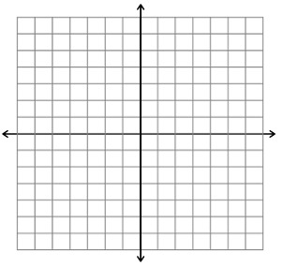

Directions: Write the equation of the function with the given transformations.

Example 4: reflection across the x-axis, left 3, down 2; quadratic function
Example 5: reflection across the y-axis, vertical stretch by 8; absolute value function
Example 6: right 7, up 9, vertical compression of ½; square root function

