Parts of a Graph – Activity
Directions: In the following activity, fill in the table, plot the points on the graph, and find the maximum or minimum, vertex, x-intercepts, and y-intercepts. Then state the shape and answer the question at the end of each category.
Example: $f\left(x\right)={(x+1)}^{2}-9$ Shape: _____________________
x | -6 | -5 | -4 | -3 | -2 | -1 | 0
y

x-intercept: __________________________

y-intercept: __________________________

Max or Min: ___________________________

Vertex: ______________________________

Interval Increasing: ____________________

Interval Decreasing: ____________________

X-Intercept: When the value of “y” is zero; where the graph crosses the x-axis.
Y-Intercept: When the value of “x” is zero; where the graph crosses the y-axis.
Maximum/Minimum: Graph comes to a high point or low point
Vertex: Highest or lowest point of a graph (x, y)

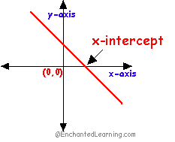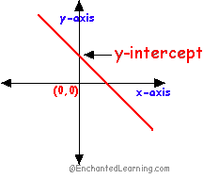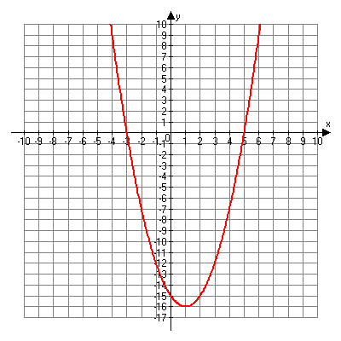
Vertex (x, y)

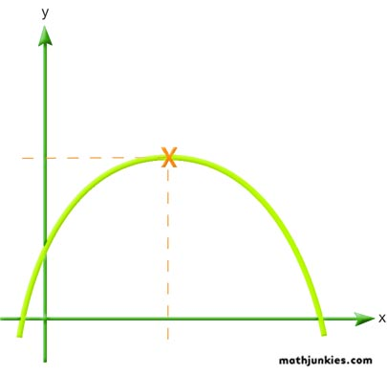
Minimum
Maximum
Parts of a Graph Activity
Absolute Value #1: $f\left(x\right)=\left|x-4\right|-2$ Shape: _____________________
x | 1 | 2 | 3 | 4 | 5 | 6 | 7
y

x-intercept: __________________________

y-intercept: __________________________

Max or Min: ___________________________

Vertex: ______________________________

Interval Increasing: ____________________

Interval Decreasing: ____________________

- What similarities do you see between the vertex and the equation?
- What part of the equation do you think gives the graph its shape?

Quadratic #1: $f\left(x\right)={(x-2)}^{2}-1$ Shape: _____________________
x | -1 | 0 | 1 | 2 | 3 | 4 | 5
y

x-intercept: __________________________

y-intercept: __________________________

Max or Min: ___________________________

Vertex: ______________________________

Interval Increasing: ____________________

Interval Decreasing: ____________________

- What similarities do you see between the vertex and the equation?
- What part of the equation do you think gives the graph its shape?

Absolute Value #2: $f\left(x\right)=-\left|x\right|+7$ Shape: _____________________
x | -3 | -2 | -1 | 0 | 1 | 2 | 3 | 4
y

x-intercept: __________________________

y-intercept: __________________________

Max or Min: ___________________________

Vertex: ______________________________

Interval Increasing: ____________________

Interval Decreasing: ____________________

- What similarities do you see between the vertex and the equation?
- Do you believe the vertex has any bearing on where the graph is located? Explain your reasoning.
- What part of the equation do you think gives the graph its shape?

Quadratic #2: $f\left(x\right)={-(x+1)}^{2}-7$ Shape: _____________________
x | -4 | -3 | -2 | -1 | 0 | 1 | 2
y

x-intercept: __________________________

y-intercept: __________________________

Max or Min: ___________________________

Vertex: ______________________________

Interval Increasing: ____________________

Interval Decreasing: ____________________

- What similarities do you see between the vertex and the equation?
- Do you believe the vertex has any bearing on where the graph is located? Explain your reasoning.
- What part of the equation do you think gives the graph its shape?

Parts of a Graph - Solutions
Absolute Value #1: $f\left(x\right)=\left|x-4\right|-2$ Shape: V
x | 1 | 2 | 3 | 4 | 5 | 6 | 7
y | 1 | 0 | -1 | -2 | -1 | 0 | 1

x-intercept: (2, 0) and (6, 0)

y-intercept: (0, 2)

Max or Min: Min

Vertex: (4, -2)

Interval Increasing: $(4, ∞)$ or $x>4$

Interval Decreasing: $(-∞, 4)$ or $x<4$

- What similarities do you see between the vertex and the equation?
The vertex and the equation share the same numbers, both have a 4 and -2, the only difference is the 4 in the equation is negative and the 4 in the vertex is positive.
- What part of the equation do you think gives the graph its shape?
The absolute value bars.

Quadratic #1: $f\left(x\right)={(x-2)}^{2}-1$ Shape: U
x | -1 | 0 | 1 | 2 | 3 | 4 | 5
y | 8 | 3 | 0 | -1 | 0 | 3 | 8

x-intercept: (1, 0) and (3, 0)

y-intercept: (0, 3)

Max or Min: Minimum

Vertex: (2, -1)

Interval Increasing: $(2, ∞)$ or $x>2$

Interval Decreasing: $(-∞, 2)$ or $x<2$

- What similarities do you see between the vertex and the equation?
The vertex and the equation share the same numbers, both have a 2 and -1, the only difference is the 2 in the equation is negative and the 2 in the vertex is positive.
- What part of the equation do you think gives the graph its shape?
The exponent of the number 2.
Absolute Value #2: $f\left(x\right)=-\left|x\right|+7$ Shape: V
x | -3 | -2 | -1 | 0 | 1 | 2 | 3
y | 4 | 5 | 6 | 7 | 6 | 5 | 4

x-intercept: (7, 0) and (-7, 0)

y-intercept: (0, 7)

Max or Min: Maximum

Vertex: (0, 7)

Interval Increasing: $(-∞, 0)$ or $x<0$

Interval Decreasing:$(0, ∞)$ or $x>0$

- What similarities do you see between the vertex and the equation?
Both share the number 7.
- Do you believe the vertex has any bearing on where the graph is located? Explain your reasoning.
Yes, it shows that the height of the graph is 7, and the graph has moved 7 units up from the origin (0, 0).
- What part of the equation do you think gives the graph its shape?
The absolute value bars.

Quadratic #2: $f\left(x\right)={-(x+1)}^{2}-7$ Shape: U
x | -4 | -3 | -2 | -1 | 0 | 1 | 2
y | -16 | -11 | -8 | -7 | -8 | -11 | -16

x-intercept: None

y-intercept: (0, -8)

Max or Min: Maximum

Vertex: (-1, -7)

Interval Increasing: $(-∞, -1)$ or $x<-1$

Interval Decreasing: $(-1, ∞)$ or $x>-1$

- What similarities do you see between the vertex and the equation?
Both contain a 1 and -7, however the vertex has a -1 and the equation contains a positive 1.
- Do you believe the vertex has any bearing on where the graph is located? Explain your reasoning.
Yes. The vertex is (-1, -7), which means the graph moved left 1 and down 7, which you can tell by looking at the graph it has.
- What part of the equation do you think gives the graph its shape?
The exponent of the number 2.

