Math 3 **1.1 Relations and Functions** Unit 1

|  |  |
| --- | --- |
| Relation: | Function: |
| Domain: | Range: |

**Example 1:**  What are the domain and range of this relation? {(-4,0), (-3,1), (0,-2), (1,2), (3,3)}

**Domain: Range: Is this a function? Why or why not?**

|  |  |  |
| --- | --- | --- |
| **Example 2**) Is this a function? Why or why not? | **Example 3**) Is this a function? Why or why not? | **Example 4**) Evaluate. Write your answer as an ordered pair.  a. , for  b. , for |

**How to tell if an equation is a function?**

Two things cannot be true:

1) y cannot be in absolute value bars

2) y cannot be raised to an even power

**Example 5)** State whether the following equations are functions:

1. y = x2 + 2 b. x = y2 – 3y c. y = 3x

**Interval Notation –** an alternative way of expressing an inequality  
Symbols:

|  |  |
| --- | --- |
| **( )** |  |
| **[ ]** |  |

Examples:

|  |  |  |
| --- | --- | --- |
| Inequality | Picture | Interval Notation |
| 2 < x < 6 |  |  |
| -3 < x < 0 |  |  |
| x > 5 |  |  |
| x < -2 |  |  |
| All real numbers |  |  |

Math 3 **1.1 Parts of a Graph** Unit 1

***Part 1:*** *Intercepts*

|  |  |
| --- | --- |
| **X – Intercepts:** |  |
| **Y – Intercept:** |

***Part 2:*** *End Behavior and Asymptotes*

|  |  |  |  |  |
| --- | --- | --- | --- | --- |
| **End Behavior:** the behavior as the graph approaches infinity & negative infinity | | | | **Asymptote** – a line which the graph approaches, but never touches  AsymptotesOneOverX |
|  |  |  |  |

***Part 3:*** *Vertex, Maximums and Minimums*

|  |  |
| --- | --- |
| **Vertex:** |  |
| **Maximum:** |
| **Minimum:** |

***Part 4:*** *Relative Maximums or Minimums* ***Part 5:*** *Intervals Increasing or Decreasing:*

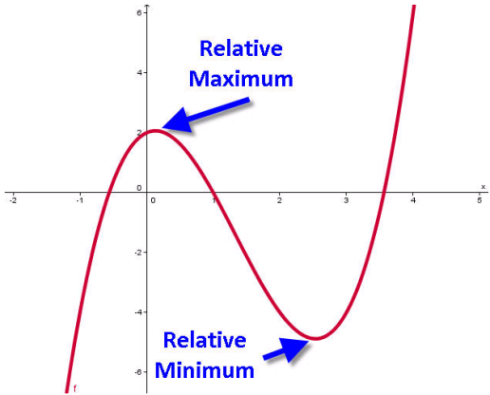

**Increasing:** for which x-values are the y-values increasing

**Decreasing**: for which x-values are the y-values decreasing

**Example 6:** Identify the intervals increasing and decreasing in the graph to the left.